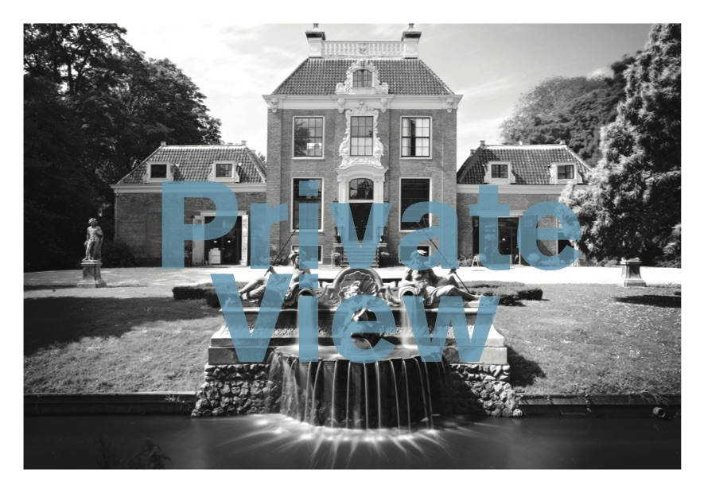
Private View
25 Years Slewe
At Huize Frankendael

06.10 – 24.11.2019

Opening Sunday
6 October 3-5 pm

Slewe Gallery is pleased to announce the upcoming exhibition Private View. 25 Years Slewe celebrating the 25th anniversary of the gallery to be held at Huize Frankendael in Amsterdam. The exhibition will consist of a selection of works by the artists shown at the gallery through the years. They are installed in the salon rooms and garden of this 18th century building. The exhibition opens Sunday October 6 and it will be on view until November 24. On the occasion a catalogue will be published with an overview of all gallery’s exhibitions and with texts by Rudi Fuchs, Martina Klein and Stephen Morse. It will be designed by Irma Boom, who was responsible for all graphic design of the gallery through the years. Also, as part of the festivities, there will be a piano concert by John Snijders, performing a contemporary music program, on Sunday November 10.

Artists participating at Private View are Adam Colton, Alan Charlton, Alan Johnston, Alice Schorbach, Callum Innes, Caro Jost, Dan Walsh, Domenico Bianchi, Günter Tuzina, Guillaume Le Roy, Ian Davenport, Irma Boom, Jan van Munster, Jan Roeland, Jerry Zeniuk, Joris Geurts, Karel Appel, Kees Smits, Krijn de Koning, Lesley Foxcroft, Lon Pennock, Marthe Wéry, Martin Gerwers, Martina Klein, Merina Beekman, Michael Jacklin, Paul Drissen, Peter Davis, Robbert-Jan Gijzen, Roos Theuws, Ruud Kuijer, Stanislav Kolíbal, Steven Aalders, Zebedee Jones.

You can visit the exhibition Sundays between 2 and 5 pm and by appointment at:
Huize Frankendael, Middenweg 72, 1092 Amsterdam

During Private View at Huize Frankendael the gallery space of Slew at the Kerkstraat gives room to two solo exhibitions. In one of the gallery spaces Amsterdam based artist Alice Schorbach, who was the very first exhibitor at Slewe 25 years ago, will show new works. The other space features new works by British sculptor Lesley Foxcroft. For Foxcroft it will be her first show at Slewe Gallery. Both artists share a fundamental approach to their medium and their delicate simple works relate to space and light of the architecture. The exhibition opens Friday September 20 and lasts until November 2.

For more information please visit www.slewe.nl or contact the gallery at info@slewe.nl.

